Project Plan

Team 4

1. Draft project plan
2. Purpose and project goals

Create an immersive AR software (e.g., a game) using Unity.

‘AR’ is the thing that add virtualization to reality. So a material that can be found in our life is best material in this app. We organized our daily materials into keywords, We catch a material called mosquitoes. A game to find and catch mosquitoes by recognizing the direction by sound.

It is our purpose to implement this game appropriately based on ar and to provide fun to users.

1. Work Division

* **Jae Min**
  + Game Designer (Main planner)
* **Jae Han**
  + Game Designer (GUI, Support 3D Assets)
  + Video Art (for Introduce our AR Games)
* **Hwi nyeon**
  + Sound (Effects, BGM, Spatial Audio)
  + Game Designer (3D Assets)
* **Hyeong chan**
  + (If we needs) Server
  + Game Designer (Support planner)

1. TimeLine

2022.03.31

- Basic Function

- (Rotate View, Surround Sound System, etc…)

2022.04.15

- GUI (Scoring, Level)

- Level Design

2022.04.29

- Complete

- Bug fix

1. FlowChart

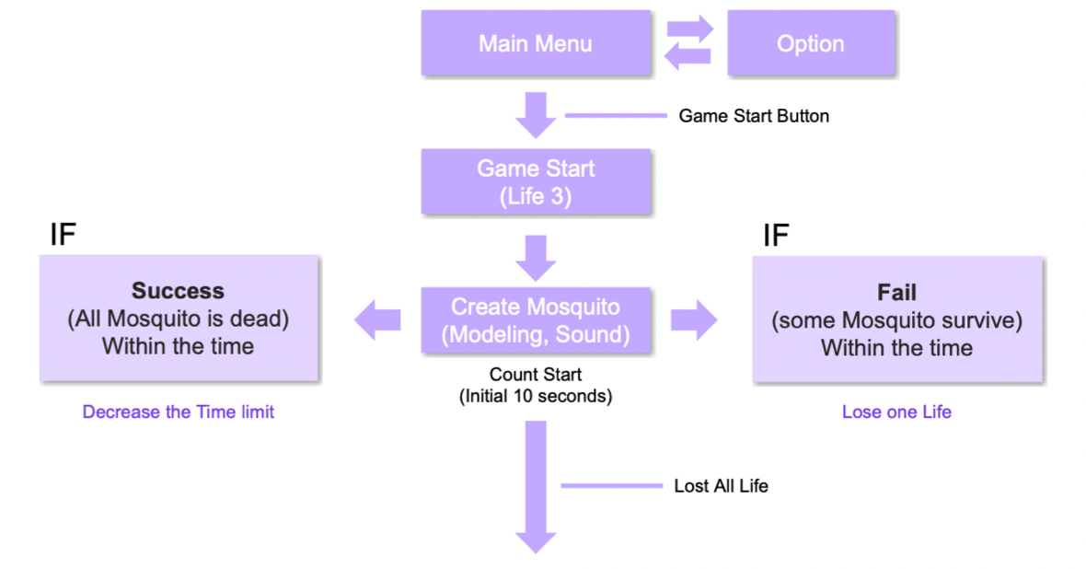

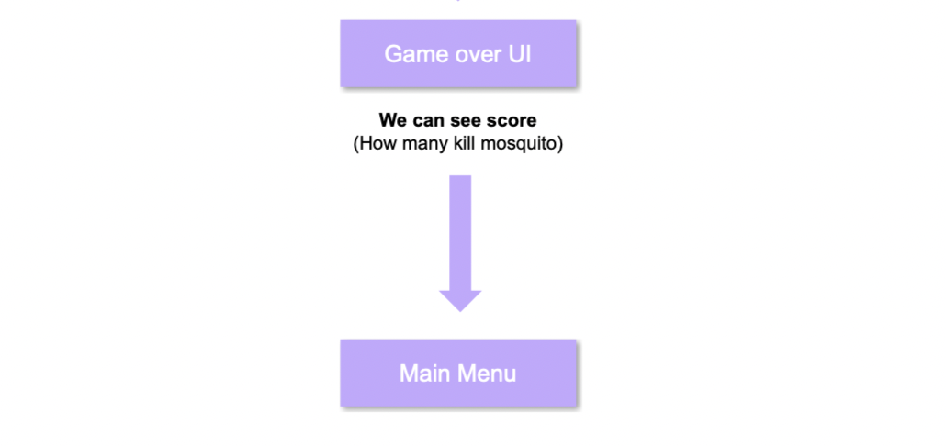

1. Actual project progress
2. Week 1 (2022.03.18 ~ 2022.03.25)

Establishment of development direction based on ‘Idea Pitch and Project Plan (Draft Project Plan)’

Gathering information about Mosquito Assets. Collection about Mosquito Sounds. Find 3D Sound Tutorial.

(Added some information about similar games.)

( Two of the crew members have been diagnosed with Corona)

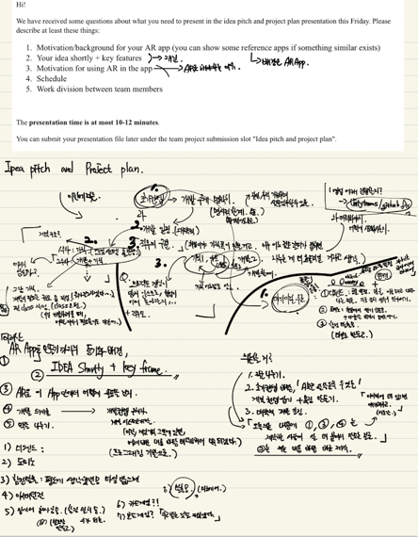 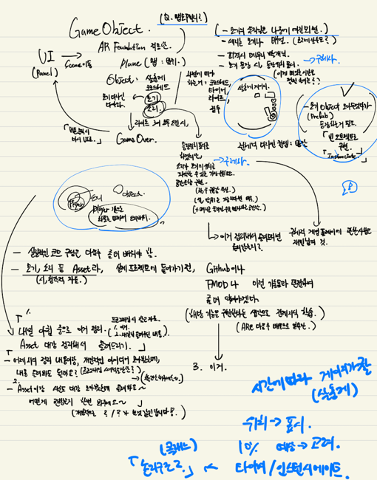 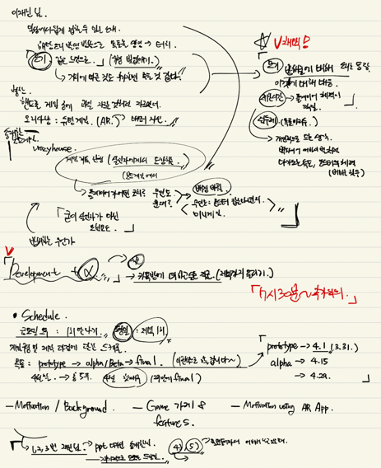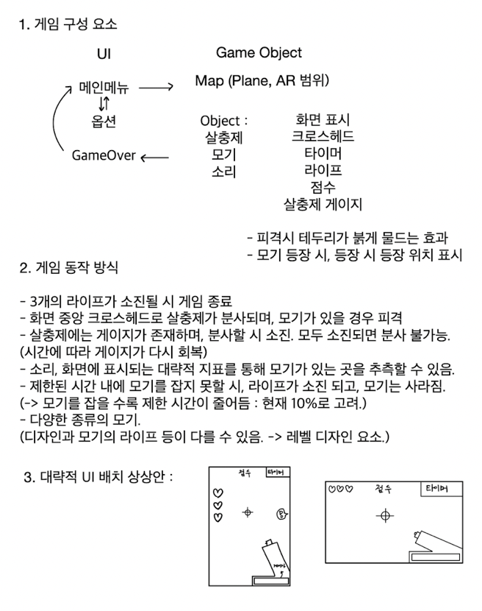 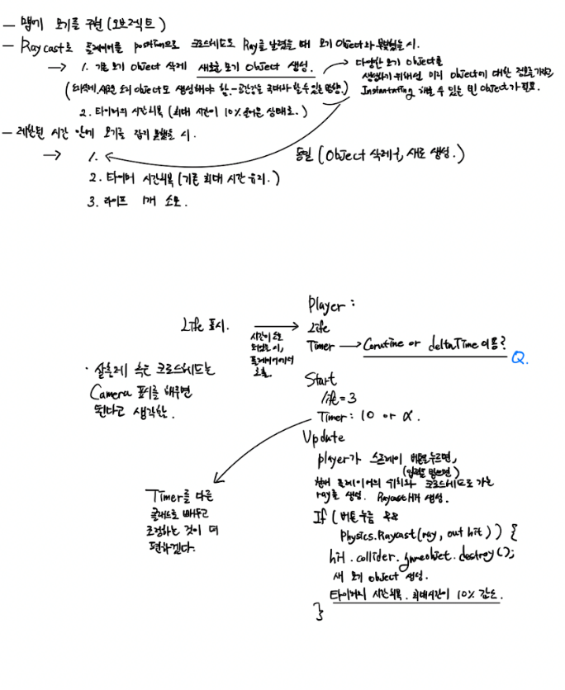

1. Week 2 (2022.03.25 ~ 2022.04.01)

Check the main goals of the project. Arrangement of functions required for development, arrangement of prototype development goals. Since we have not yet learned about the ar function, we discuss how to implement the logic in 3d.

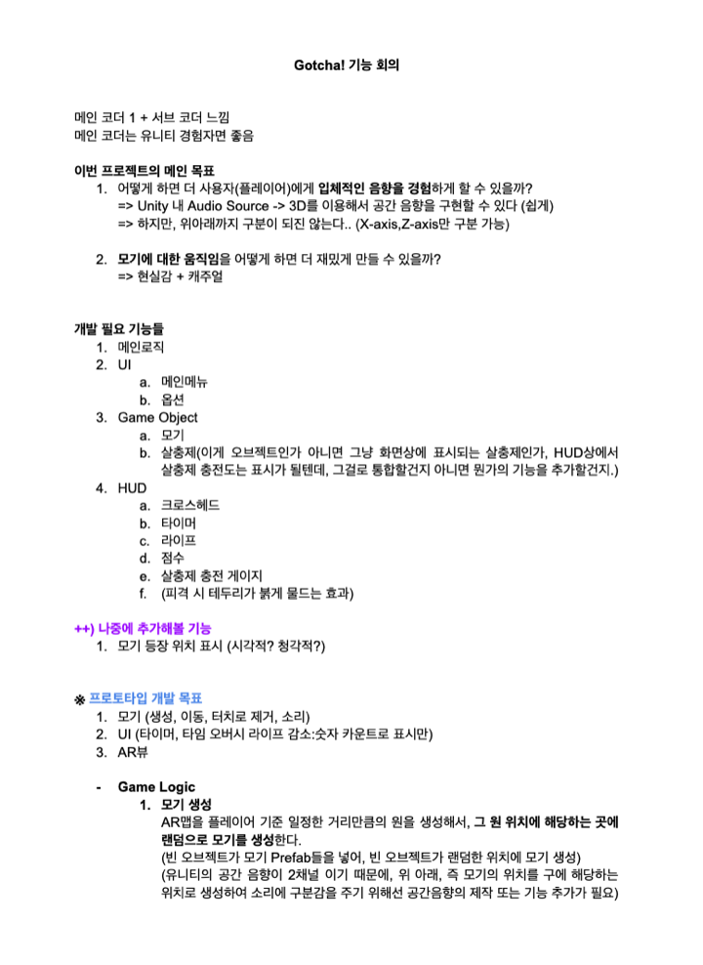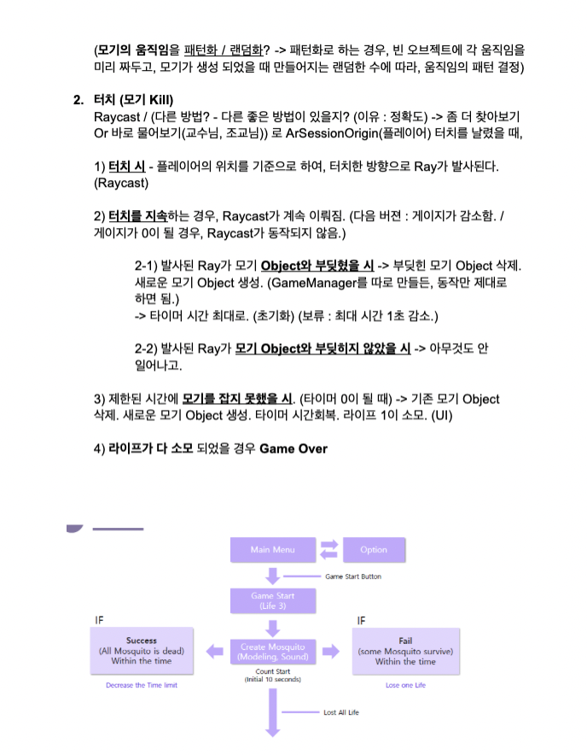

After this, the main designer implemented the overall function. The rest of the developers decided to implement detailed functions in detail.

1. Week 3 (2022.04.01 ~ 2022.04.08)

Complete implementation of the simple overall game play, and mosquito movements and spawners in detail. Confirmed that the implementation of the game is not that difficult. Discussing how to implement as ar and how to apply spatial sound. Divide the development part according to each person.

(JeaMin : Player, Hwinyeon : Mosquito, JeaHan : GameManager, HyeonChan : Spawner)

Refine gameplay with flowcharts.

Each implementation is at ourselves discretion, but We need to discuss how each script will interact with each other. So make Class Diagram. Discussion of changes. (Player and HUD, UI, etc.)

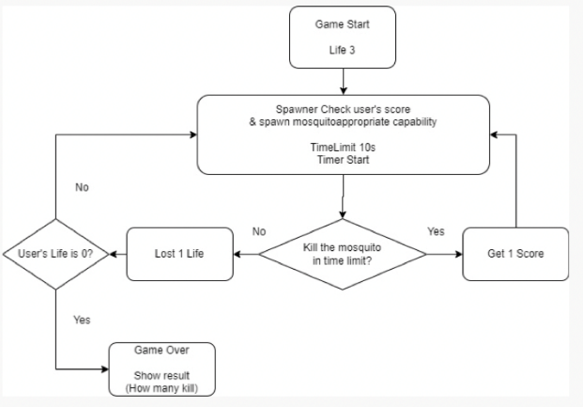 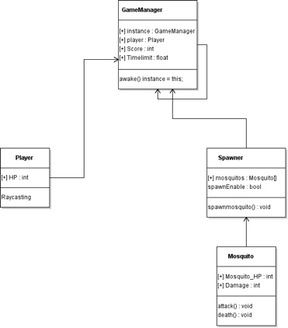

Initial Flowchart and Class Diagram

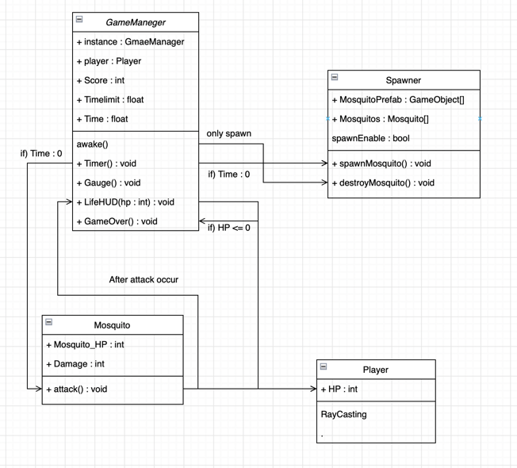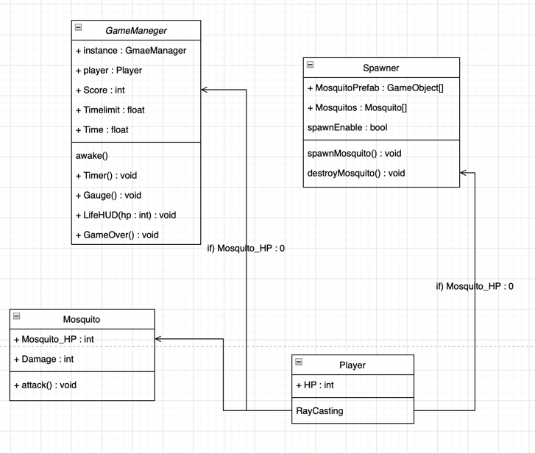

Additional class diagrams

After this, We developed our respective parts.

1. Week 4 (2022.04.08 ~ 2022.04.15)

Mosquito Object development completed. Player completed, but there are a few errors. UI and Spawner partially completed. First, complete unfinished parts and correct errors for each object.

Many problems occurred due to conflicts in the merge process. Need to improve proficiency in Version Control using Github. We discussed about Conflict. -> In Main, only the working version of the branch is uploaded, and one more sub-branch is parsed and intergrated.

Found solutions to issues with resolution, game manager, and build speed in Unity. Used singleton design pattern.

Continue to develop and integrate. Some contentious existence of unfinished parts of Spawner. Although some functions were tailored to the class diagram, it was quite difficult in the integration process because they were all different. Resolved various issues such as Mosquito's position not moving even if the camera position is moved

The UI and GameManager have a large volume, so the deadline is generous. Integrates only gameplay (Spawn, Raycast, Mosquito).

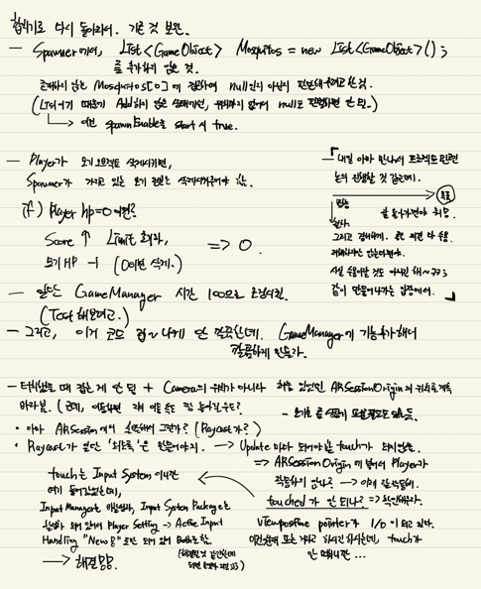 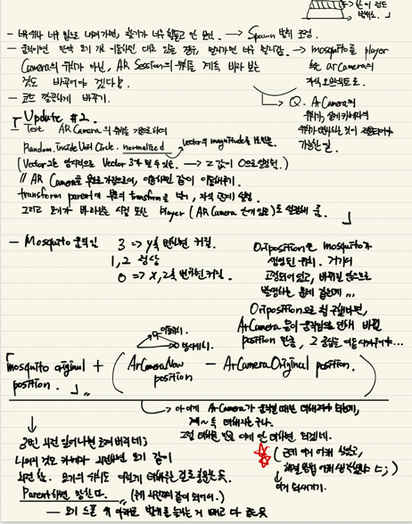 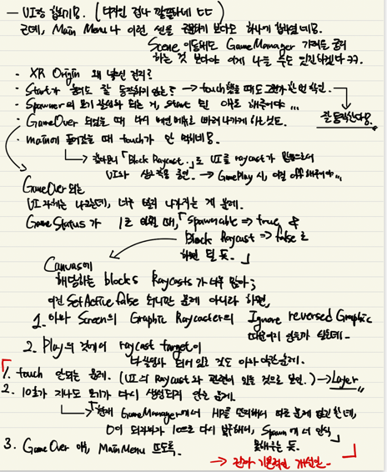

Some of the integrated workarounds

UI integration proceeds after GamePlay integration is completed. We made a prototype, but various problems exist. And Looking for a way to further develop the game.

1. Week 5 (2022.04.15 ~ 2022.04.20)

The process of solving various problems. Problems that are not touchable, do not generate mosquitoes over time, crosshead resolution or related to game level design.

the initial setting is wrong, and the Touch does not work properly. Raycast, etc. I dig a lot of Debug.Log separately, check where the problem occurs, and confirm that the touch itself does not work.

Resolved by adjusting Input Handling to Both.

Also, the problem of raycast being covered by UI is solved by using Layermask.

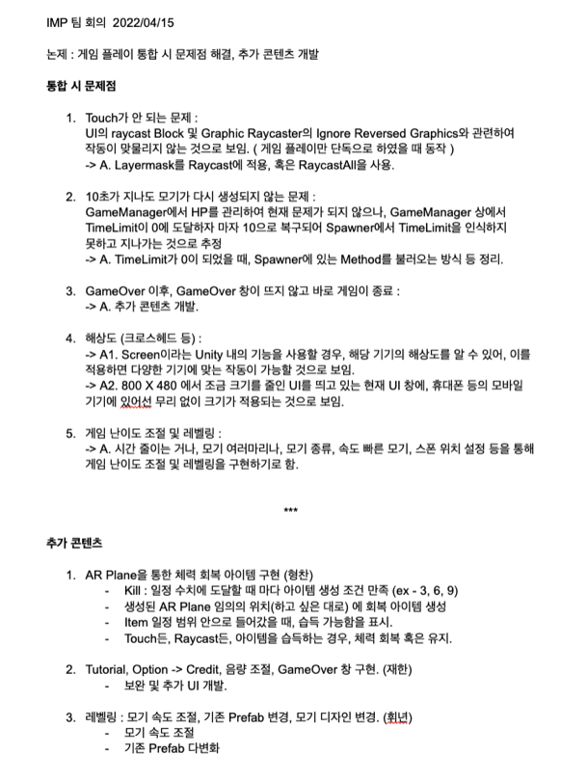

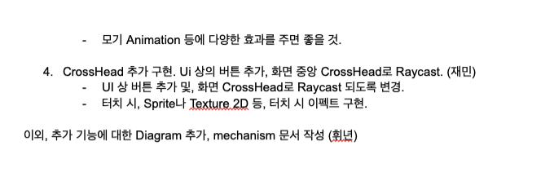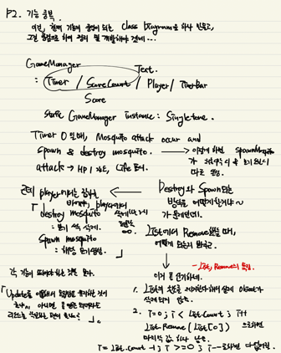 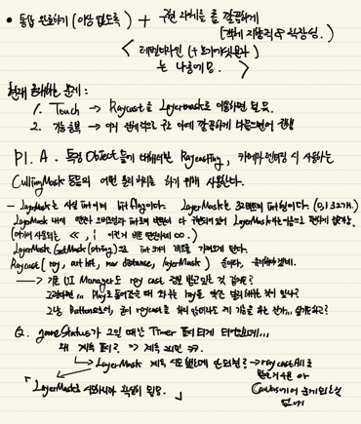

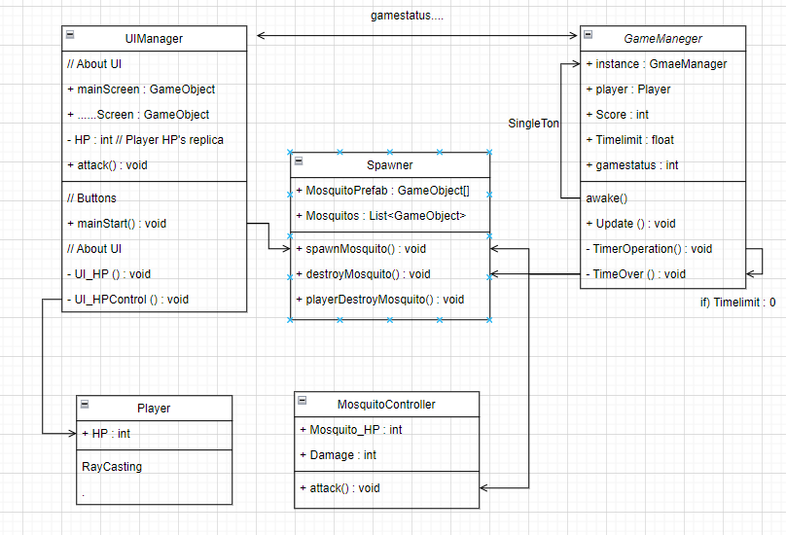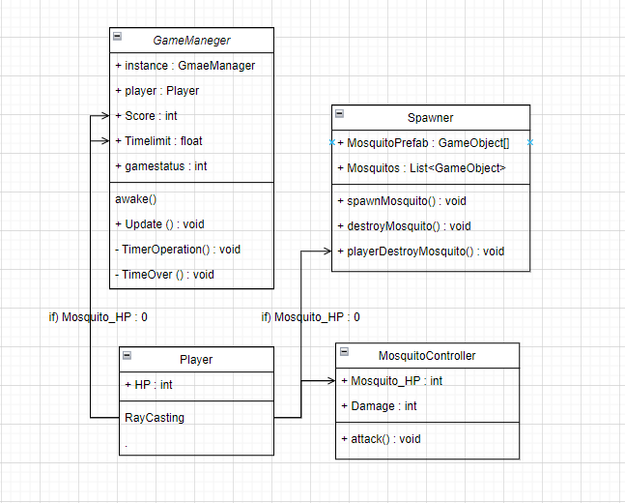

Modified the class diagram during the integration process.

Unlike the previous week where only GamePlay was completed, Prototype development was completed.

In addition, each of the additional development items is distributed and proceeded.

( Potion item using AR Plane (HyeongChan), Implementing a player-scoped raycast (JeaMin), intergrated and Leveling (Mosquito Diversification) (HwiNyeon), UI Update (Tutorial Credit GameOver etc.) (JeaHan) )

1. Week 6 (2022.04.20 ~ 2022.04.29)

Additional development items Update. (player-scoped raycast, Leveling, UI Update, Intergrated) There were some errors, but they were resolved during the integration process. Plane Potion had a lot of volume and had quite a few problems, so after discussing the error, we had some more development time.

After that, we discuss aspects that can improve the game again. After determining the development direction, it is distributed and developed again.

( Added vibration function, hit animation, sound (HwiNyeon), Spray and Player Visual (JeaMin), AR Plane Potion further development (HyeongChan), About UI – Highest Score, 321, Tutorial etc (JeaHan) )

(추후 개발 경과에 따라서 추가 작성 필요.)

1. Game Version

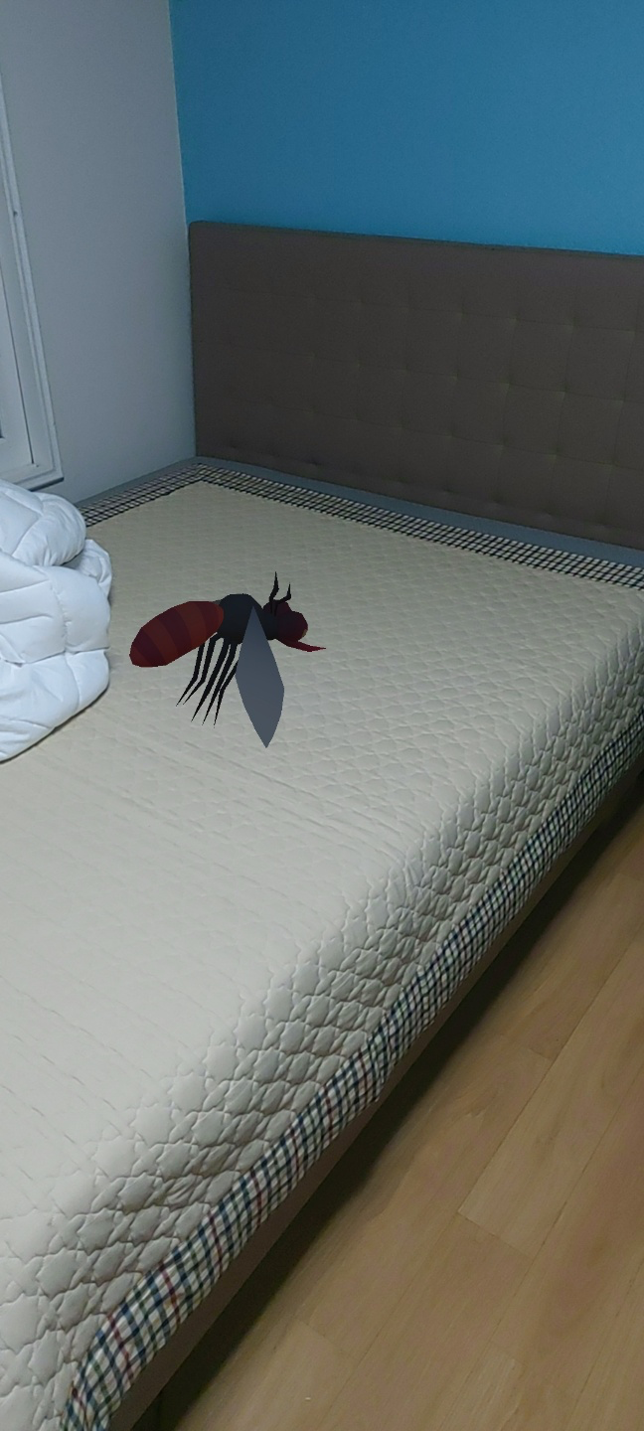  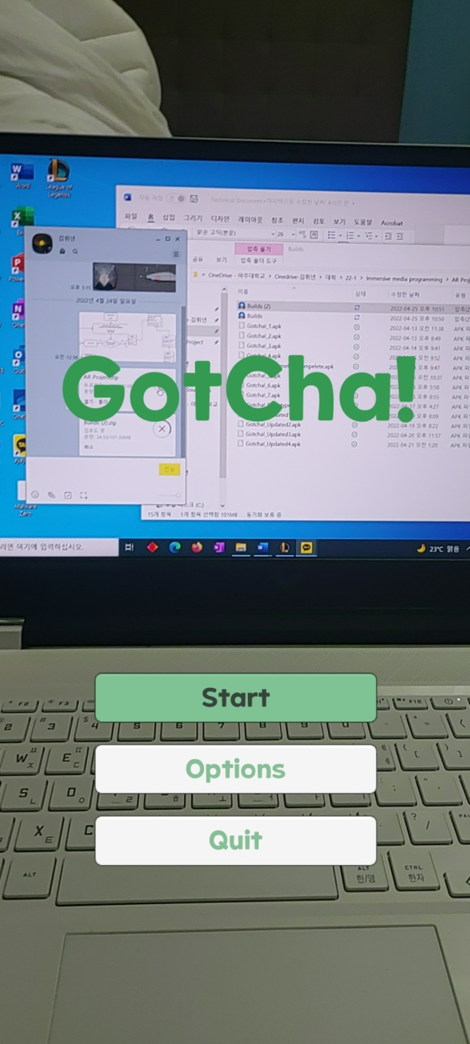 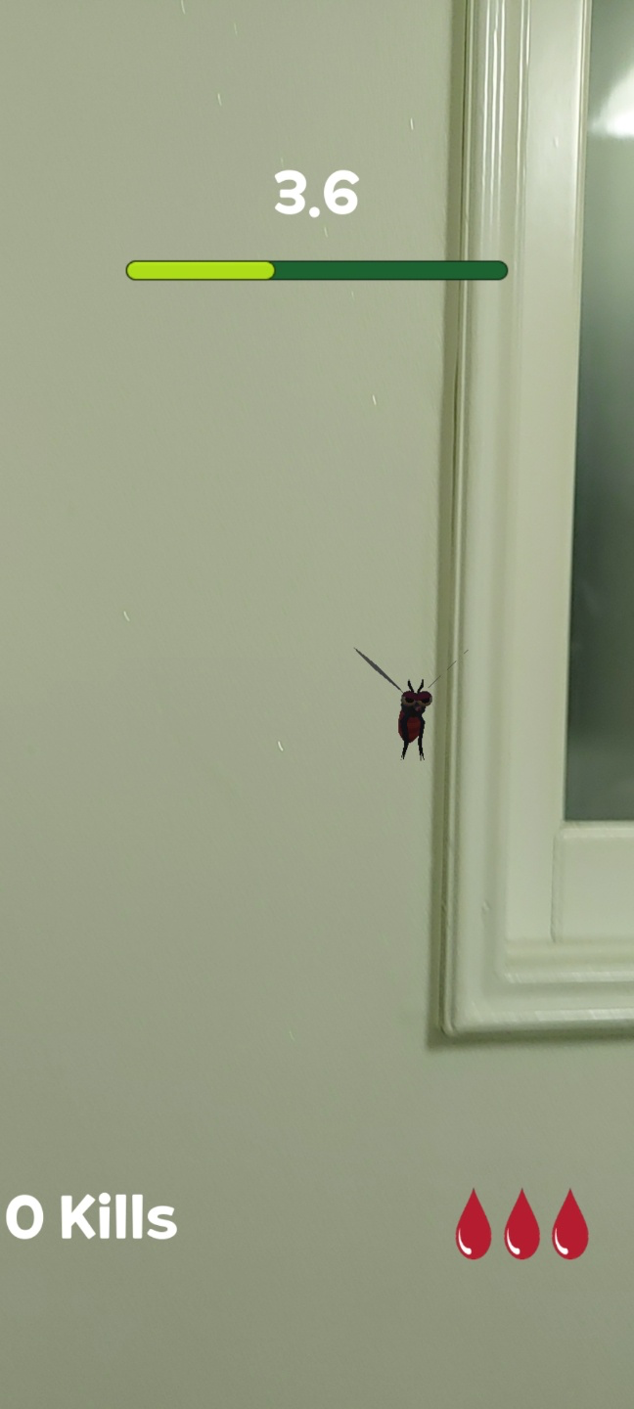

Week 3 ~ 4

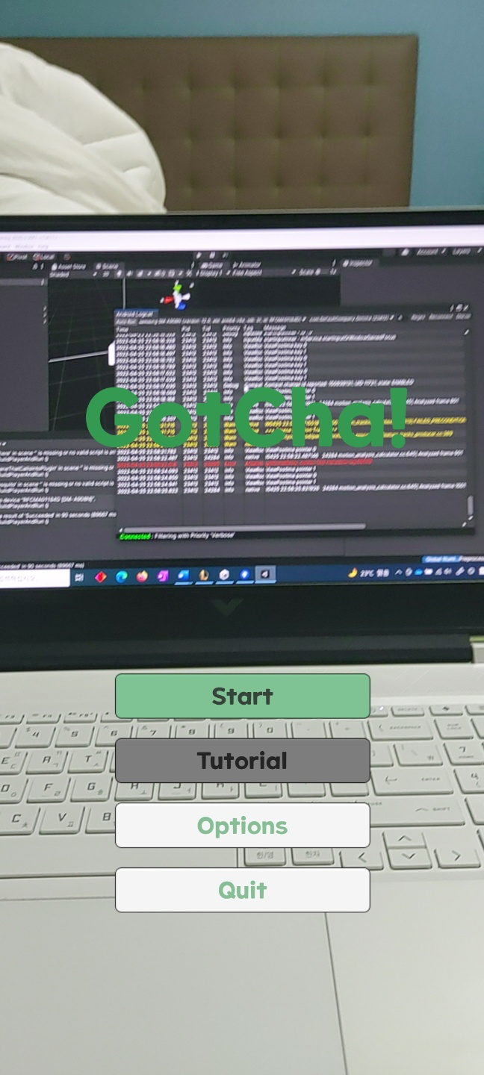 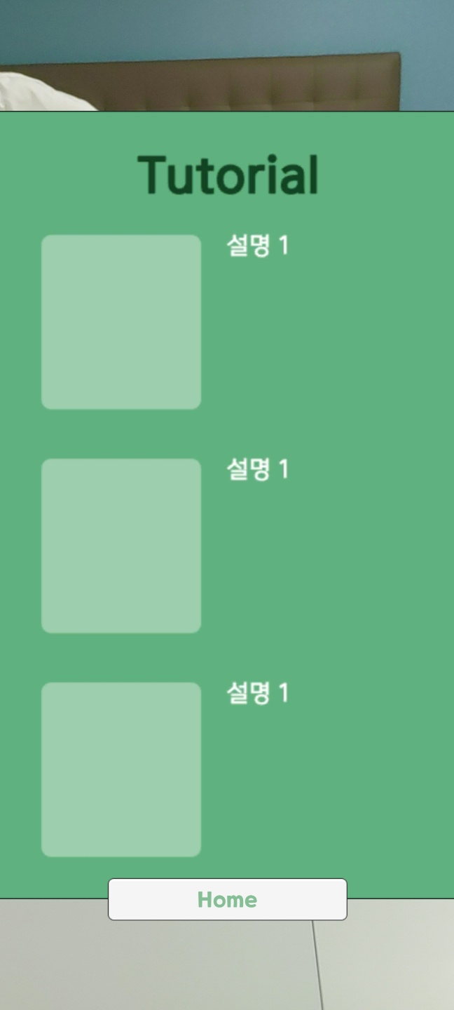 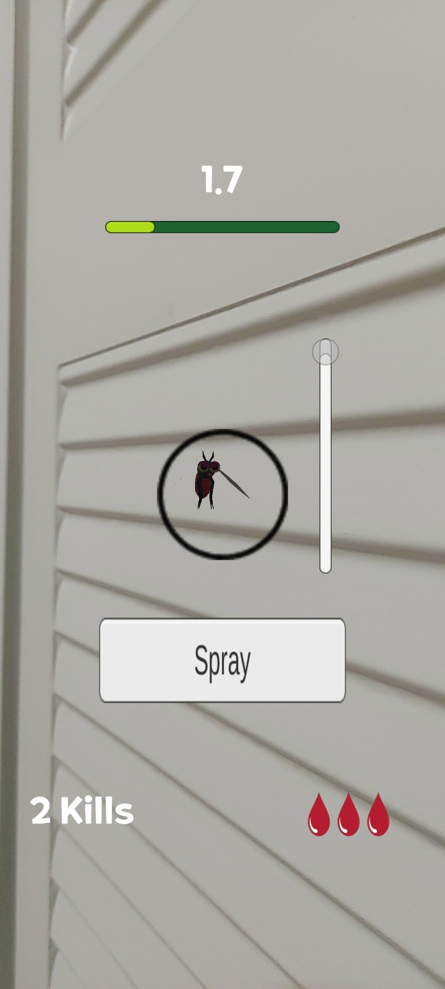 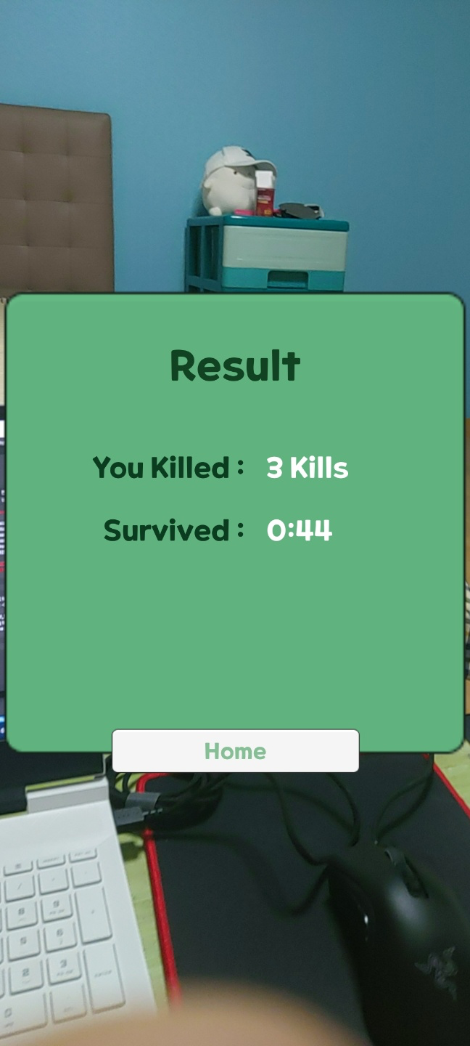 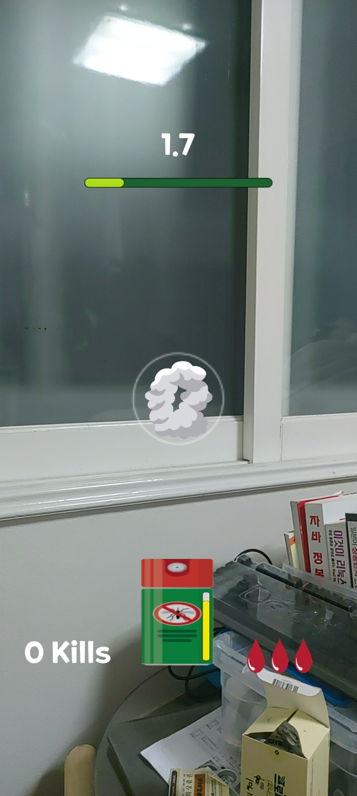

Week 4 ~ 6

1. Resource references

* Visuals

<https://www.freepik.com/free-vector/cartoon-smoke-element-animation-frames_13763535.htm#page=2&query=smoke&position=11&from_view=search>

(Spraying Smoke)

<https://ko.depositphotos.com/115599622/stock-illustration-repellent-spray-insect.html>

(Pesticide)

<https://assetstore.unity.com/packages/3d/characters/animals/insects/mosquito-bug-cute-series-215373>

(Mosquito)

<https://www.flaticon.com/>

(Headset, HP Icon)

<https://noonnu.cc/font_page/676>

(Font, Onestore mobile POP)

<https://assetstore.unity.com/packages/3d/props/tools/survival-game-tools-139872>

(first aid kit)

* Sounds

MosquitoFlayBy_BU01.555 - Insectopedia with Blastwave FX

(Mosquito Fly)

ESM_Positive_Score_Bling_4_Sound_FX_Arcade_Casino – Advanced Game Sound with Epic Stock Media

(Mosquito Catch)

ESM_Game_Over_v2_Sound_FX_Arcade_Casino - Advanced Game Sound with Epic Stock Media

(Game Over – Life all Lose)

Self Production

(Main UI Music)